**COOKBOOK IMPORTANT NOTES**

**Chapter 1:**

**1.To change the port id (if any error occur in the port id)**

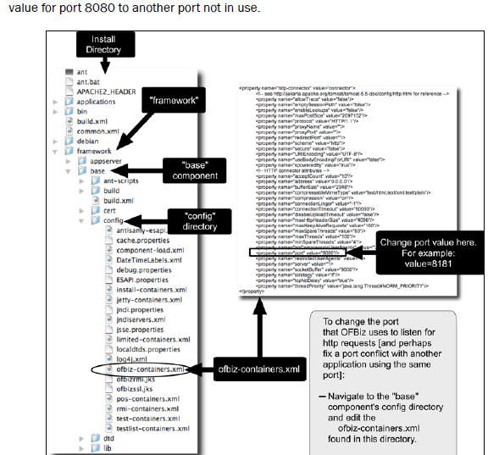

**Chapter 2:**

**2.Normal workflow of an ofbiz framework**

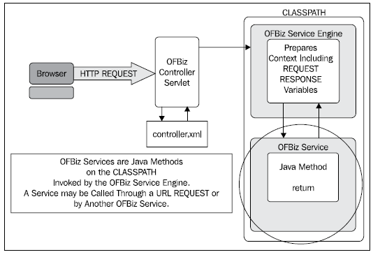

**Chapter 3:**

**3.work Flow of an ofbiz UI ,it connected with the backend functions**

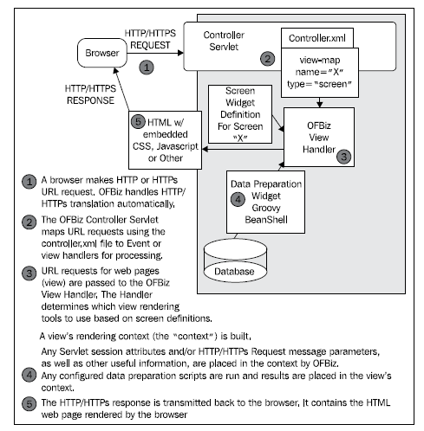

**4.View map Screening with redirecting page example**

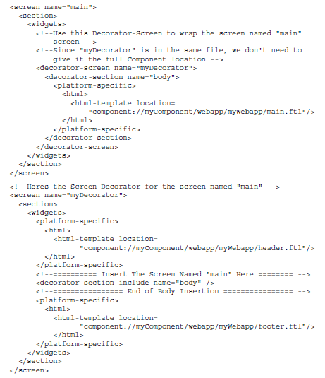

**5.Response types:**

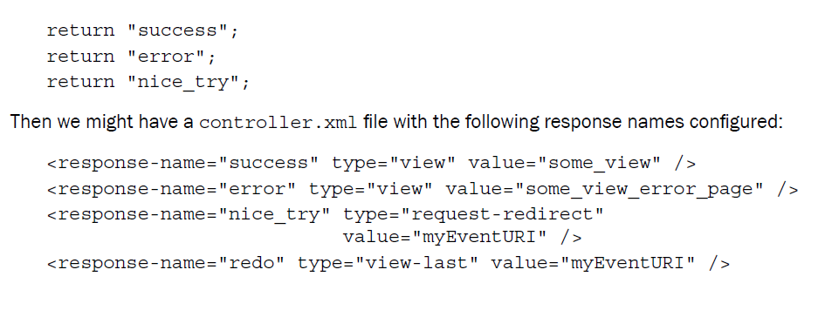

**6.To create link in ofbiz structured format**

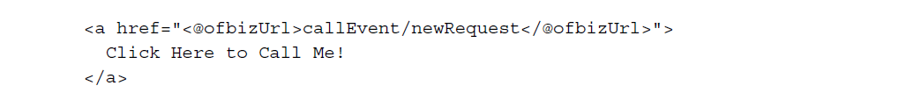

**7.To retrieve an value using groovy ,FTL(FreeMakerTemplate) and xml .**

